**ERD Diagram for Project Management**

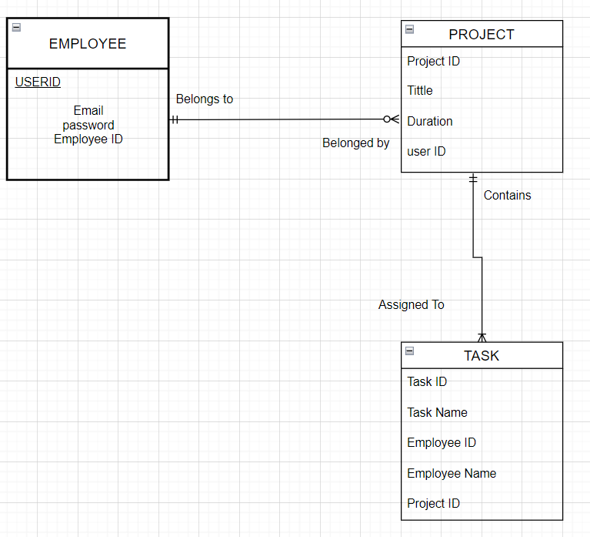

Business Rules

1. <A EMPLOYEE> <may><Belongs to><any number><PROJECT>
2. A employee may belongs to any number of projects but a project must belongs to an employee
3. <PROJECT><must><Contains> <any number>< TASK>
4. A PROJECT must contains any number of TASK. However, each Task assigned to one project

Note: Here in employee entity. The employee are only managers as per their role they can only access projects